

International School

**Capstone Project 1**

CMU-SE 450

**User Interface Design Document**

Version 1.1

Date: 23/09/2020

**viBOTour - Smart Chatbot for Tourist 4.0**

**Submitted by**

Sang, Nguyen Thanh

Thuyen, Pham Van

Tuan, Doan Kim

Loc, Phung Hoang Phu

**Approved by** Nguyen Duc Man

PROJECT INFORMATION

|  |  |  |  |
| --- | --- | --- | --- |
| **Project acronym** | viBOTour | | |
| **Project Title** | Smart Chatbot for Tourist 4.0 | | |
| **Start Date** | 24 Aug 2020 | **End Date** | 5 Dec 2020 |
| **Lead Institution** | International School, Duy Tan University | | |
| **Project Mentor** | Man, Nguyen Duc, Ph.D | | |
| **Scrum master / Project Leader & contact details** | Sang, Nguyen Thanh  Email: [thanhsang3111999.ntb@gmail.com](mailto:thanhsang3111999.ntb@gmail.com) Tel: 0344684069  ID: 23211212363 | | |
| **Partner Organization** |  | | |
| **Project Web URL** |  | | |
| **Team members** | Name | Email | Tel |
| 2321121321 | Tuan, Doan Kim | [doantuan21101999@gmail.com](mailto:doantuan21101999@gmail.com) | 0913622928 |
| 2321124963 | Loc, Phung Hoang Phu | [phunghoangphuloc@gmail.com](mailto:phunghoangphuloc@gmail.com) | 0912698173 |
| 2321125061 | Thuyen, Pham Van | [phamvanthuyen2802@gmail.com](mailto:phamvanthuyen2802@gmail.com) | 0795697332 |

REVISION HISTORY

|  |  |  |  |  |
| --- | --- | --- | --- | --- |
| Version | Date | Comments | Author | Approval |
| 1.0 | 01/09/2020 | Initial Release | Tuan |  |
| 1.1 | 23/09/2020 | Add web design | Tuan |  |

TABLE OF CONTENTS

**1. Introduction** 4

**1.1 Purpose** 4

**1.2 Scope** 4

**2. Describe User Interface Application in Detail** 4

**2.1 UI-Tourist** 4

2.1.1 UI-01: Home 4

2.1.2 UI-02: Detail Tour 5

2.1.3 UI-03: Shopping cart 6

2.1.4 UI-04: Chatbot – text 7

2.1.5 UI-05: Chatbot – voice 8

2.1.6 UI-06: Notification 9

2.1.7 UI-07: Profile 10

2.1.8 UI-08: Profile 11

2.1.9 UI-09: Login 12

2.1.10 UI-10: Sign up 13

**2.2 Web Home** 14

**2.3 UI-Admin** 15

2.3.1 View User 15

2.3.2 Invite user 15

**2.4 UI-Staff** 16

2.4.1 View Promotion 16

2.4.2 View Voucher 16

2.4.3 Create Promotion 17

2.4.4 Create voucher 18

2.4.5 View Tour 19

**2.5 UI-Manager** 19

2.5.1 View report 19

# Introduction

## Purpose

* This document serves the purpose of specifying application’s UI design

## Scope

* Create complete interfaces, and describe them clearly.
* Overview of the stages and modules of the system.

# Describe User Interface Application in Detail

## UI-Tourist

### UI-01: Home

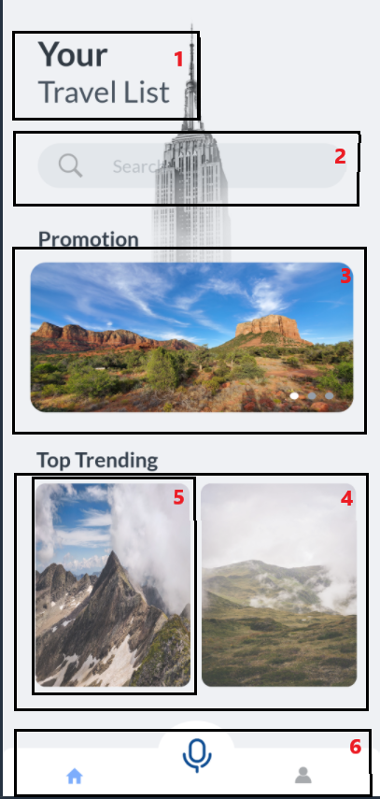

|  |  |  |  |  |
| --- | --- | --- | --- | --- |
| ID | Condition | Control Type | Target | Notes |
| 1 | Nothing | Picture | Logo of app |  |
| 2 | Click | Text box | enter the name of the tour you want to search |  |
| 3 | Click | Picture | View promotion |  |
| 4 | Scroll | List | List of 10 hottest tours |  |
| 5 | Click | Picture | Photos, tour basic information include: name, price, rate, click on will go to respective details page of the tour |  |
| 6 | Click | Tab navigation | For site navigation, there are icons representing the respective pages |  |

### UI-02: Detail Tour

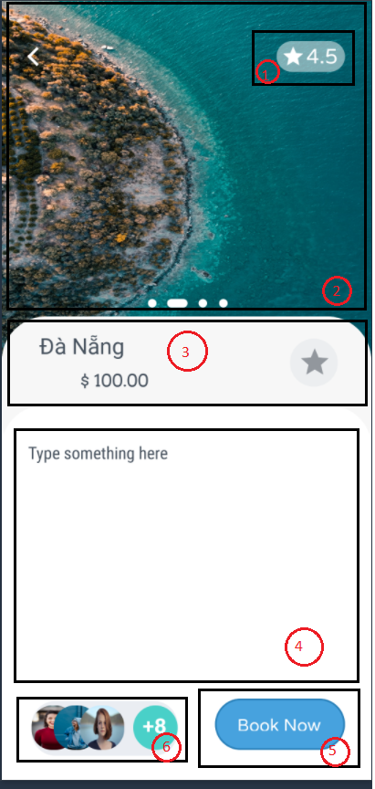

|  |  |  |  |  |
| --- | --- | --- | --- | --- |
| ID | Condition | Control Type | Target | Notes |
| 1 | Nothing | Text | Rate of tour |  |
| 2 | Scroll | Picture | Picture list of tour |  |
| 3 | Nothing | Text | Tour basic information include tour name, tour price and button to review tour |  |
| 4 | Scroll | Text | Tour detail information |  |
| 5 | Click | Button | Book a tour |  |
| 6 | Nothing | List | List of customers who have used the tour |  |

### UI-03: Shopping cart

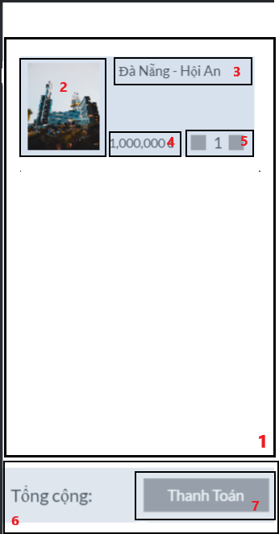

|  |  |  |  |  |
| --- | --- | --- | --- | --- |
| ID | Condition | Control Type | Target | Notes |
| 1 | Scroll | List | List of booked tours |  |
| 2 | Noting | Picture | Picture of tour |  |
| 3 | Nothing | Text | Name of tour |  |
| 4 | Noting | Text | Price of tour |  |
| 5 | Click | Button | Change the number of tickets you want to book |  |
| 6 | Nothing | Text | The total amount payable for the trip selected for payment |  |
| 7 | Click | Button | Pay for selected tours |  |

### UI-04: Chatbot – text

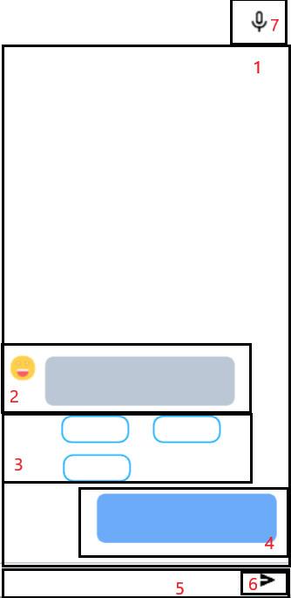

|  |  |  |  |  |
| --- | --- | --- | --- | --- |
| ID | Condition | Control Type | Target | Notes |
| 1 | Scroll | List | Chat display, scrollable to review old chats |  |
| 2 | Noting | Text | The answer is given by chatbot |  |
| 3 | Nothing | Text | The suggestion is given by chatbot |  |
| 4 | Noting | Text | The question is given by tourist |  |
| 5 | Click | Text box | Enter the question the tourist want to ask |  |
| 6 | Click | Button | Submit the question of tourist |  |
| 7 | Click | Button | Switch to chat with voice chatbot |  |

### UI-05: Chatbot – voice

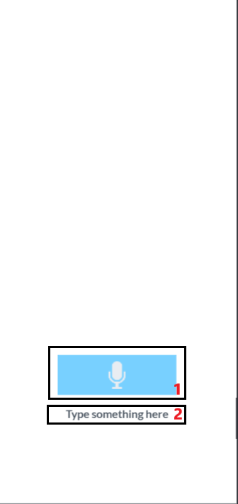

|  |  |  |  |  |
| --- | --- | --- | --- | --- |
| ID | Condition | Control Type | Target | Notes |
| 1 | Press and hold | Button | Press and hold to start speaking |  |
| 2 | Noting | Text | Show what tourist have said as text |  |

### UI-06: Notification

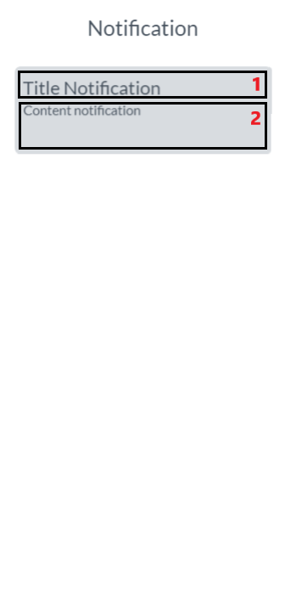

|  |  |  |  |  |
| --- | --- | --- | --- | --- |
| ID | Condition | Control Type | Target | Notes |
| 1 | Click | Text | Title notification |  |
| 2 | Noting | Text | Centent notification |  |

### UI-07: Profile

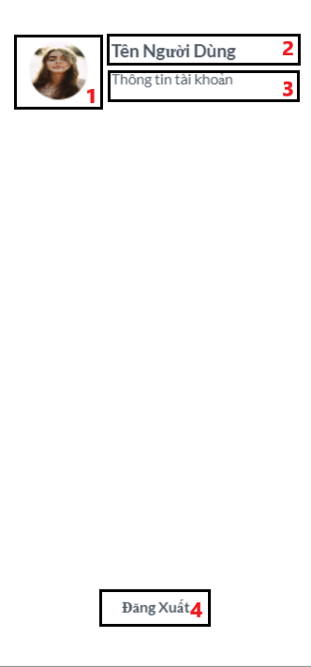

|  |  |  |  |  |
| --- | --- | --- | --- | --- |
| ID | Condition | Control Type | Target | Notes |
| 1 | Nothing | Picture | Avatar of tourist |  |
| 2 | Nothing | Text | Name of tourist |  |
| 3 | Click | Text | When clicking switch to the detailed profile page |  |
| 4 | Click | Button | Clicking on the tourist will log out of the account |  |

### UI-08: Profile

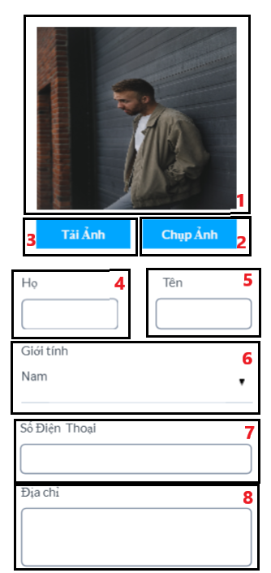

|  |  |  |  |  |
| --- | --- | --- | --- | --- |
| ID | Condition | Control Type | Target | Notes |
| 1 | Nothing | Picture | Show recently uploaded avatar or current avatar |  |
| 2 | Click | Button | Use your phone's camera to capture and upload avatars |  |
| 3 | Click | Button | Use stock photo as avatar |  |
| 4 | Click | Text box | Enter the tourist first name |  |
| 5 | Click | Text box | Enter the tourist last name |  |
| 6 | Click | Combo box | Choose the tourist gender |  |
| 7 | Click | Text box | Enter the tourist number phone |  |
| 8 | Click | Text box | Enter the tourist address |  |

### UI-09: Login

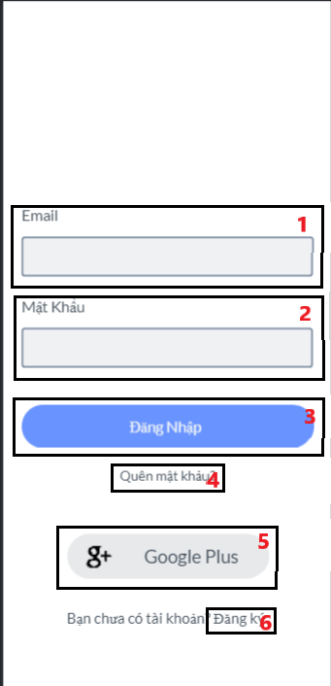

|  |  |  |  |  |
| --- | --- | --- | --- | --- |
| ID | Condition | Control Type | Target | Notes |
| 1 | Click | Text box | Enter the registered email |  |
| 2 | Click | Text box | Enter the registered password |  |
| 3 | Click | Button | Login on the system |  |
| 4 | Click | Text | Reset their password when a tourist forgets it |  |
| 5 | Click | Button | Sign in with the tourist google account |  |
| 6 | Click | Text | Sign up a new account |  |

### UI-10: Sign up

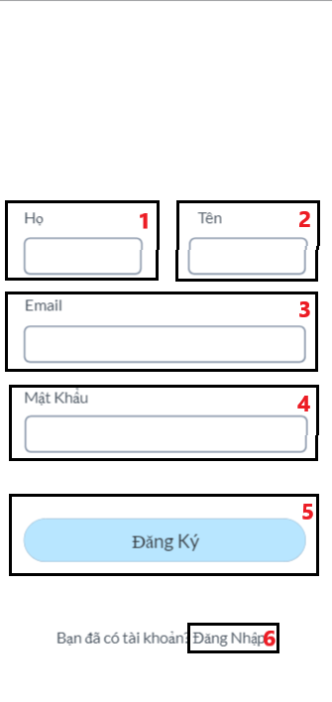

|  |  |  |  |
| --- | --- | --- | --- |
| ID | Condition | Control Type | Target |
| 1 | Click | Text box | Enter the tourist first name |
| 2 | Click | Text box | Enter the tourist last name |
| 3 | Click | Text box | Enter the tourist email |
| 4 | Click | Text box | Enter the tourist password |
| 5 | Click | Button | Sign up a new account |
| 6 | Click | Text | Login if you already have an account |

* 1. **Web Home**

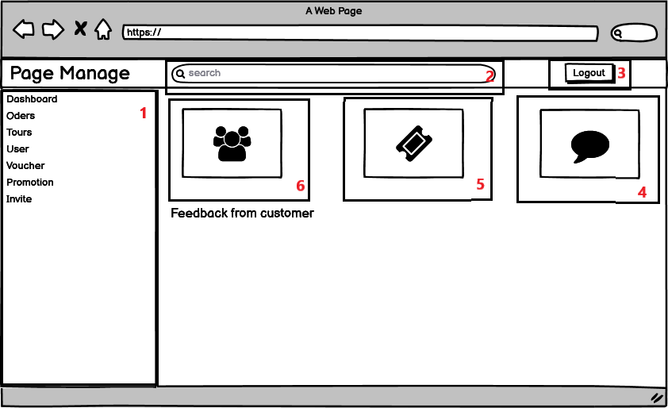

|  |  |  |  |
| --- | --- | --- | --- |
| ID | Condition | Control Type | Target |
| 1 | Click | List | Tab navigation |
| 2 | Click | Text box | Search information for tour |
| 3 | Click | Button | Logout of the system |
| 4 | Click | Something | To see all comments on the tours |
| 5 | Click | Something | To see all tiket sold |
| 6 | Click | Something | To see all users |

## UI-Admin

* + 1. **View User**

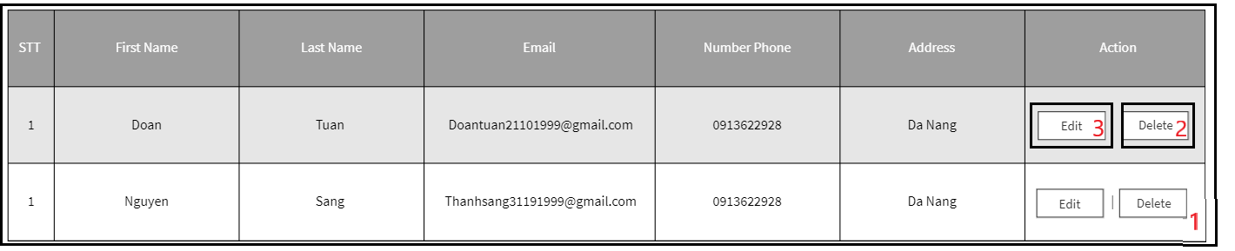

|  |  |  |  |
| --- | --- | --- | --- |
| ID | Condition | Control Type | Target |
| 1 | Click | Table | Show basic information of users |
| 2 | Click | Button | Delete user |
| 3 | Click | Button | Edit information of user |

* + 1. 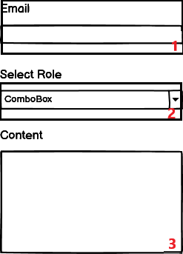**Invite user**

|  |  |  |  |
| --- | --- | --- | --- |
| ID | Condition | Control Type | Target |
| 1 | Click | Text box | Enter email |
| 2 | Click | Combo box | Choose role for user |
| 3 | Click | Text area | Enter the content of the letter |

* 1. **UI-Staff**
     1. **View Promotion**

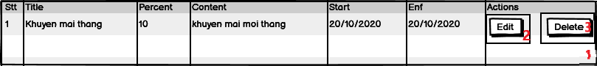

|  |  |  |  |
| --- | --- | --- | --- |
| ID | Condition | Control Type | Target |
| 1 | Click | Table | Show basic information of promotion |
| 2 | Click | Button | Delete promotion |
| 3 | Click | Button | Edit information of promotion |

* + 1. **View Voucher**

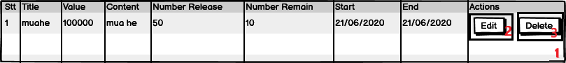

|  |  |  |  |
| --- | --- | --- | --- |
| ID | Condition | Control Type | Target |
| 1 | Click | Table | Show basic information of voucher |
| 2 | Click | Button | Delete voucher |
| 3 | Click | Button | Edit information of voucher |

* + 1. **Create Promotion**

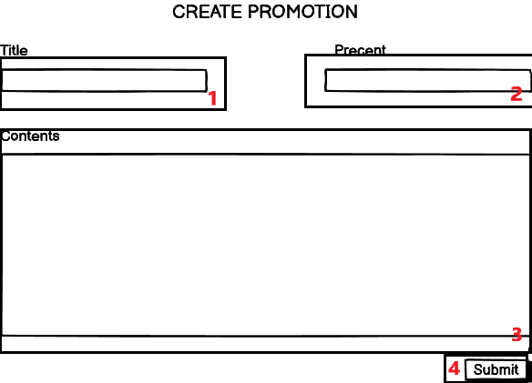

|  |  |  |  |
| --- | --- | --- | --- |
| ID | Condition | Control Type | Target |
| 1 | Click | Text box | Enter title of promotion |
| 2 | Click | Text box | Enter percent discount |
| 3 | Click | Text area | Edit content of promotion |
| 4 | Click | Button | Add promotion |

* + 1. **Create voucher**

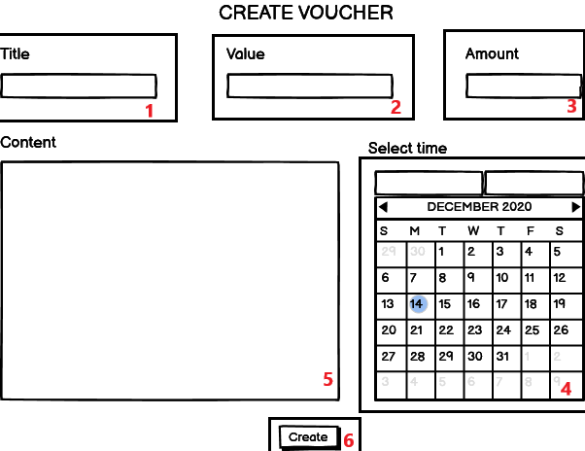

|  |  |  |  |
| --- | --- | --- | --- |
| ID | Condition | Control Type | Target |
| 1 | Click | Text box | Enter title of promotion |
| 2 | Click | Text box | Enter value discount |
| 3 | Click | Text box | Edit amount of voucher |
| 4 | Click | calendar | Select start date and end date |
| 5 | Click | Text area | Edit content of voucher |
| 6 | Click | Button | Add voucher |

* + 1. **View Tour**

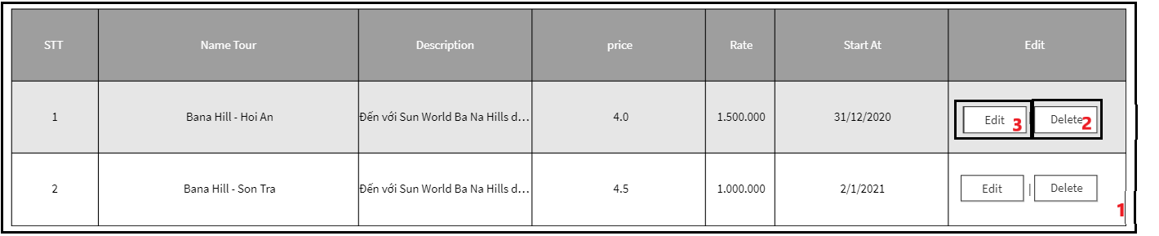

|  |  |  |  |
| --- | --- | --- | --- |
| ID | Condition | Control Type | Target |
| 1 | Click | Table | Show basic information of tour |
| 2 | Click | Button | Delete tour |
| 3 | Click | Button | Edit information of tour |

* 1. **UI-Manager**
     1. **View report**

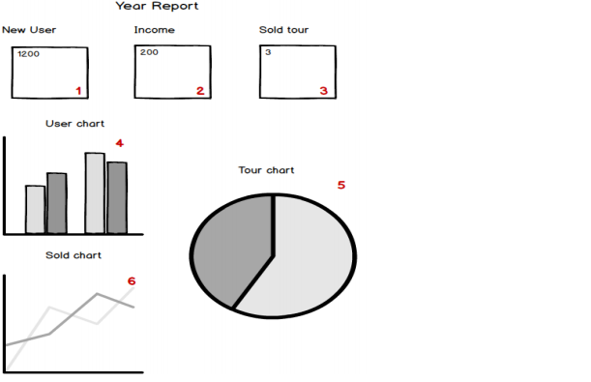

|  |  |  |  |
| --- | --- | --- | --- |
| ID | Condition | Control Type | Target |
| 1 | Nothing | Label | Show total number User |
| 2 | Nothing | Label | Show total number Income |
| 3 | Nothing | Label | Show total number Sold tour |
| 4 | Nothing | Chart | Show Chart about User |
| 5 | Nothing | Chart | Show Chart about Tour |
| 6 | Nothing | Chart | Show Chart about Sold Tour |